Chapter No :2

System Analysis

A feasibility study is a test of a system proposal according to its workability, impact on the organization, ability to meet user needs, and effective use of resources. For system project feasibility is assessed in three principal ways:

1. Technical
2. Economical
3. Operational

**2.1.1 Technical Feasibility**

Technical feasibility is frequently the most difficult area because objectives functions and performance are somewhat hazy. It essentials that the process of analysis and conduct in parallel with an assessment of technical feasibility. The equipment and other items are currently available in market.

**2.1.2 Economic Feasibility**

To develop the new system and meet the future needs, we suggest that a Pentium-IV computer is required to operate functionally well now and in the future, Windows XP or 2000 Operating system. To print the reports, there must be a printer with moderate quality. The time of the management is also considered so that less time spends on the project but further information is required time by time.

**2.1.3 Operational Feasibility**

An operational feasible system is one that will be used effectively after it has been developed. If users have difficulty with new system then it will not produce the expected benefits. User friendly interface make it easier for the user to navigate through the web site. The purposed system will be user friendly and menu driven and end user will operate the system efficiently after some training. The computer operators are also required to operate on that system and we will also give training to the operators how input data and how to output data.

**2.2 Existing System: Data Gathering**

After conducting a comprehensive study of the existing system of the MIC I found that the present system is working manually and there is redundancy in maintaining the information about the patients, doctors etc.

* The existing system costs approximately 96.2 million.
* Existing system is working in different areas of the hospital that are:
* Accounting
* Medical Store
* Doctors
* Labs
* This system is used for billing, patient records, doctors’ records, employees etc. The system generates reports for the patient billing and other records.
* There are following reports used in existing systems of Emergency of Multan Institute of Cardiology.
* Reports about patients
* Reports about Tests
* Reports for patient progress
* Patient’s medicine report
* Doctors Schedule
* Reports about Doctor
* Patient History
* The invoices are generated for patients, purchased medicine for Paying and General Categories patients.

**2.3 Methods of Investigation**

There are three major ways for getting the information. These three major ways are:

1. Questionnaire
2. On-site observation
3. Interviews

**2.3.1 Questionnaires**

This investigation process is used for the technical information getting. Sometimes there is a part of information that is not possible to get by the above two techniques, so we also used questionnaire process for investigation the required information**.**

**2.3.2 On-Site Observation**

We analyzed the existing system in many ways. We visited the department and took information from staff and from the chairman too. So in that way we had found some important information**.**

**2.3.3 Interviews**

The investigation is made by conducting the interviews. The interview of employees is being made. So due to this method of investigation we got a lot of useful information which is provided to us by the employees in the light of their experiments.

**2.4 Existing System: Data Analysis**

On studying the existing system of Emergency, I found too many drawbacks in the system. Some of the major drawbacks are as follows:

1. The management has less information about the patients.
2. Processing of the necessary data is too much slow because of the manual working.
3. It was too difficult to store necessary data in different files.
4. Same information is stored in different departments resulted data redundancy.
5. Doctors have no information about patients’ history.
6. Patient can’t get online appointment from doctor.
7. Patient can’t get information about different diseases.
8. Management does not know much about the Emergency patients’ information.
9. Searching of previous patients is difficult.
10. Reports were not accurate developed by system i.e. a great headache.
11. No perfect system to handle the Doctor’s data.
12. Difficult to modify the existing data.
13. There is a lot chance of data unavailability at the time.
14. Slow entry and retrieval of data.
15. No way for online access of documents.

**2.4.1 Data Flow Diagram (DFD)**

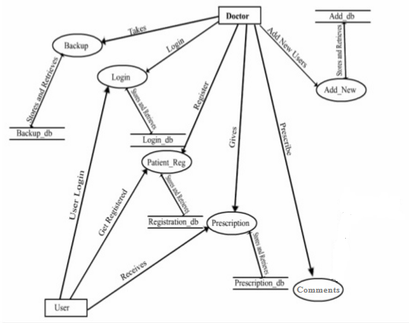

**Data Flow Diagram**